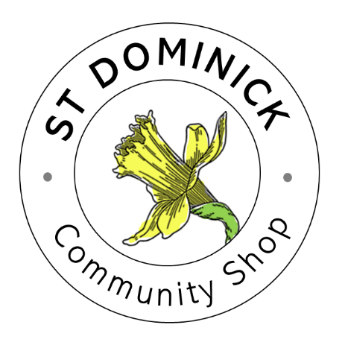

ST DOMINICK COMMUNITY SHOP LOTTERY
TERMS & CONDITIONS
The operation of the Lottery scheme for St Dominick Community Shop will give customers the opportunity to enter a weekly lottery and win a jackpot prize if their number is drawn.
The lottery will run from Monday through to Saturday each week. During this period, lottery numbers can be purchased for the week’s draw. The lottery will close on Saturday evening each week.
Customers (must be aged 16 or over) can buy up to a maximum of 3 lottery numbers at a cost of £2.00 for each number. Any number or numbers purchased are only valid for that week’s draw.
The customer will be required to write their name and contact details against the number they have purchased on the weekly lottery register.
For each number bought the customer will receive a till receipt with their lottery number marked on the receipt. The receipt automatically prints the date of purchase so the date of that week’s lottery will be recorded.
The customer must retain the receipt with their lottery number marked on the receipt as that will be required to redeem any jackpot winnings.
The size of the jackpot each week will be determined by the number of lottery numbers purchased. For each number purchased, £1.00 will go into the jackpot.
The winning number each week will be decided by the National Lottery main Lotto bonus ball number drawn on each Saturday evening.
If the winning number has not been purchased in any week the jackpot winnings will be rolled over to the following week.
Any jackpot winnings will be paid in cash and can be collected after midday each Monday on presentation of the receipt with the lottery number marked on it.
In the event of a dispute, the decision of the Shop Management Board will be final.
The Shop Management Board reserves the right to review and amend these terms & conditions from time to time.
August 2025

